**--> Question 2.1 What are the Top 25 schools (.edu domains)?**

**Ans:**

SELECT

email_domain,

COUNT(*)

FROM users

WHERE email_domain LIKE '%.edu'

GROUP BY 1

ORDER BY 2 DESC

LIMIT 25;

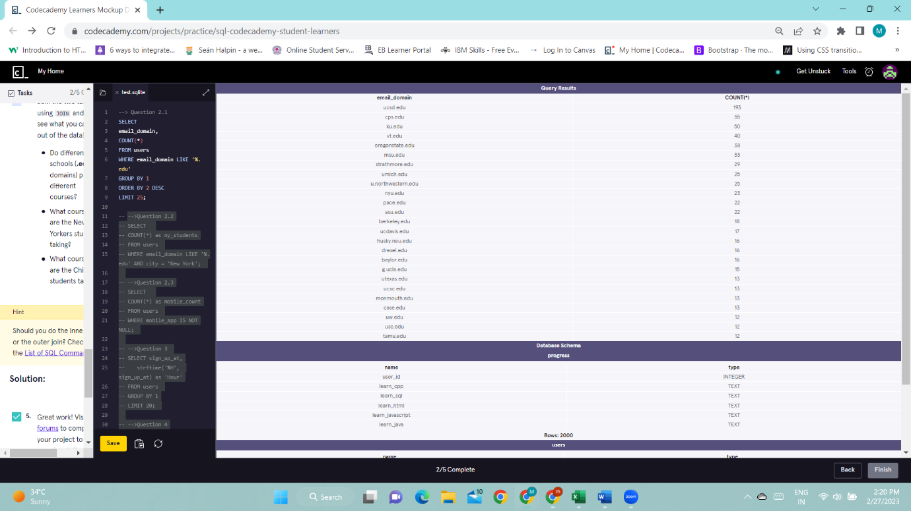

**-->Question 2.2 How many .edu learners are located in New York?**

**Ans:**

SELECT

COUNT(*) as ny_students

FROM users

WHERE email_domain LIKE '%.edu' AND city = 'New York';

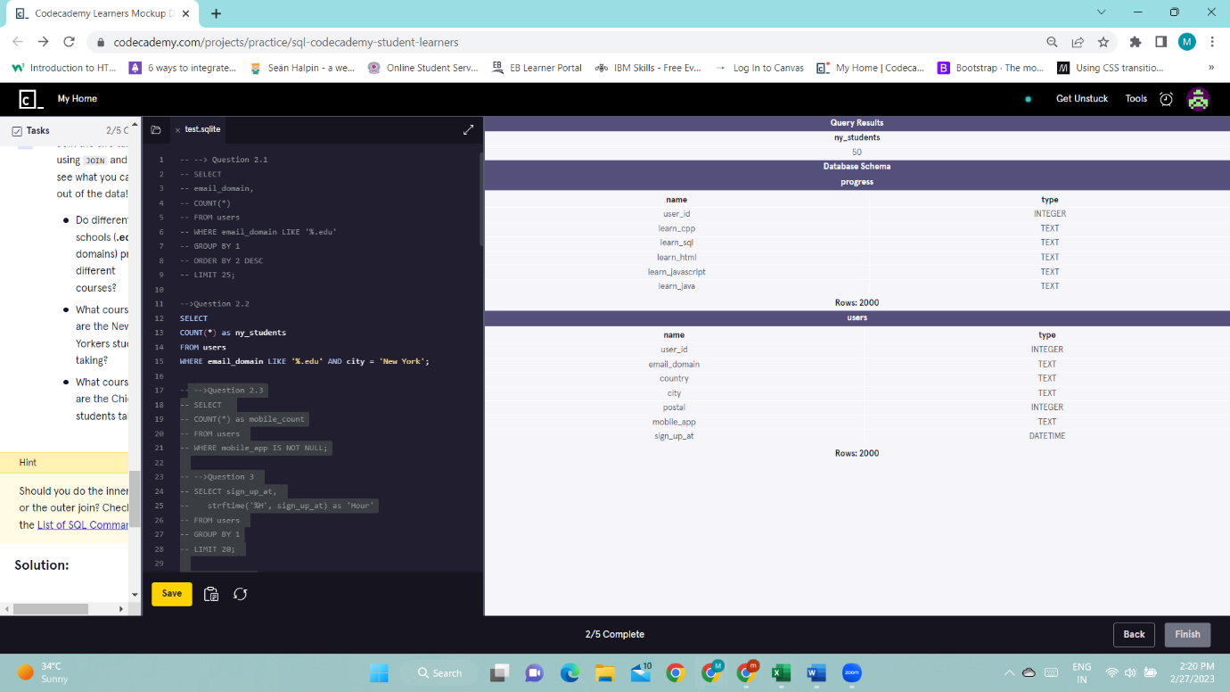

**-->Question 2.3 The mobile_app column contains either mobile-user or NULL. How many of these Codecademy learners are using the mobile app?**

**Ans:**

SELECT

COUNT(*) as mobile_count

FROM users

WHERE mobile_app IS NOT NULL;

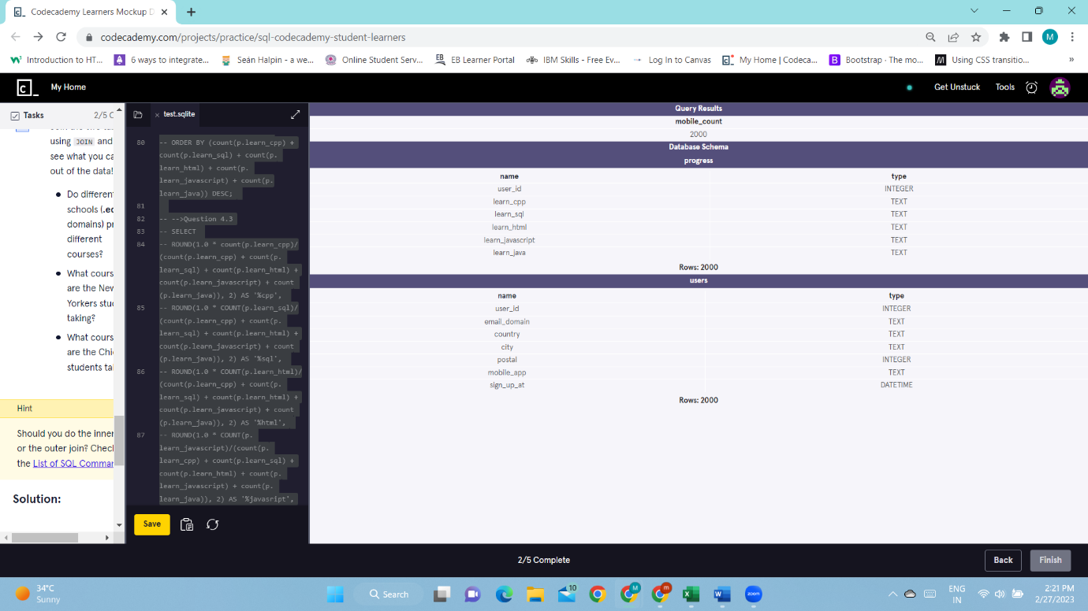

**-->Question 3**

**The data type of the sign_up_at column is DATETIME. It is for storing a date/time value in the database.**

**Notice that the values are formatted like:**

**2015-01-01 18:33:52**

**So the format is:**

**YYYY-MM-DD HH:MM:SS**

**SQLite comes with a strftime() function - a very powerful function that allows you to return a formatted date.**

**It takes two arguments:strftime(format, column)**

**Let’s test this function out:**

**SELECT sign_up_at,**

**strftime('%S', sign_up_at)**

**FROM users**

**GROUP BY 1**

**LIMIT 20;Now, using this function, query for the sign up counts for each hour.**

**Ans:**

SELECT sign_up_at,

strftime('%H', sign_up_at) as 'Hour'

FROM users

GROUP BY 1

LIMIT 20;

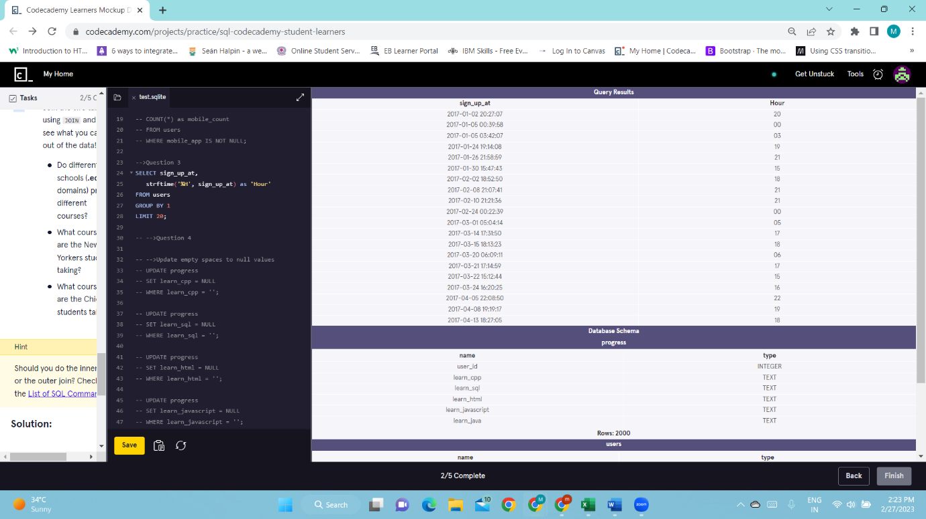

**-->Question 4 Join the two tables using JOIN and then see what you can dig out of the data!**

**Ans:**

-->Update empty spaces to null values

UPDATE progress

SET learn_cpp = NULL

WHERE learn_cpp = '';

UPDATE progress

SET learn_sql = NULL

WHERE learn_sql = '';

UPDATE progress

SET learn_html = NULL

WHERE learn_html = '';

UPDATE progress

SET learn_javascript = NULL

WHERE learn_javascript = '';

UPDATE progress

SET learn_java = NULL

WHERE learn_java = '';

**-->Question 4.1 Do different schools (.edu domains) prefer different courses?**

**Ans:**

SELECT

email_domain,

ROUND(1.0 * count(p.learn_cpp)/(count(p.learn_cpp) + count(p.learn_sql) + count(p.learn_html) + count(p.learn_javascript) + count(p.learn_java)), 2) AS '%cpp',

ROUND(1.0 * COUNT(p.learn_sql)/(count(p.learn_cpp) + count(p.learn_sql) + count(p.learn_html) + count(p.learn_javascript) + count(p.learn_java)), 2) AS '%sql',

ROUND(1.0 * COUNT(p.learn_html)/(count(p.learn_cpp) + count(p.learn_sql) + count(p.learn_html) + count(p.learn_javascript) + count(p.learn_java)), 2) AS '%html',

ROUND(1.0 * COUNT(p.learn_javascript)/(count(p.learn_cpp) + count(p.learn_sql) + count(p.learn_html) + count(p.learn_javascript) + count(p.learn_java)), 2) AS '%javasript',

ROUND(1.0 * COUNT(p.learn_java)/(count(p.learn_cpp) + count(p.learn_sql) + count(p.learn_html) + count(p.learn_javascript) + count(p.learn_java)), 2) AS '%java'

FROM users u

JOIN progress p

ON u.user_id = p.user_id

WHERE email_domain LIKE '%.edu'

GROUP BY 1

ORDER BY (count(p.learn_cpp) + count(p.learn_sql) + count(p.learn_html) + count(p.learn_javascript) + count(p.learn_java)) DESC

LIMIT 10;

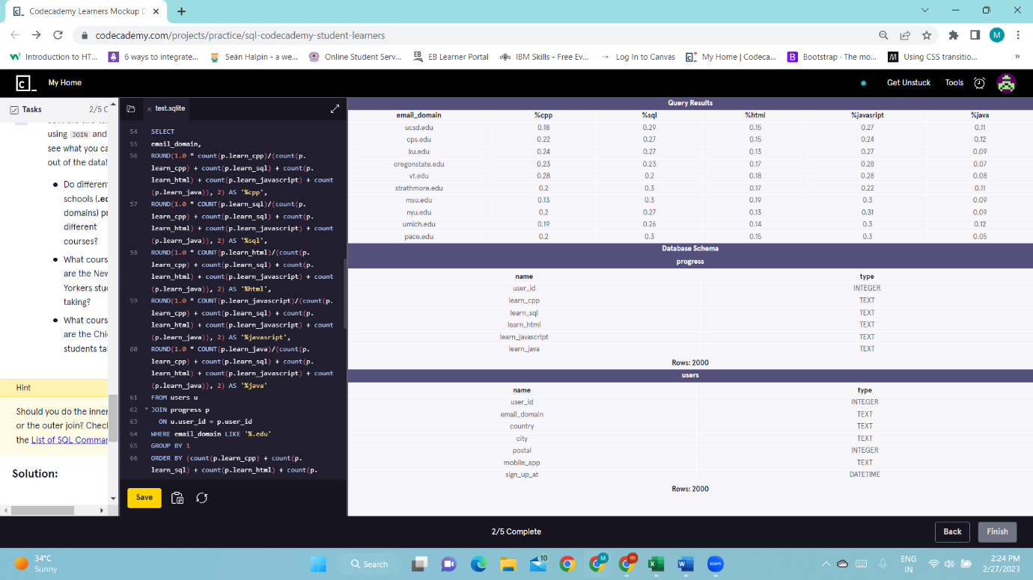

**--Question 4.2 What courses are the New Yorkers students taking?**

**Ans:**

SELECT

ROUND(1.0 * count(p.learn_cpp)/(count(p.learn_cpp) + count(p.learn_sql) + count(p.learn_html) + count(p.learn_javascript) + count(p.learn_java)), 2) AS '%cpp',

ROUND(1.0 * COUNT(p.learn_sql)/(count(p.learn_cpp) + count(p.learn_sql) + count(p.learn_html) + count(p.learn_javascript) + count(p.learn_java)), 2) AS '%sql',

ROUND(1.0 * COUNT(p.learn_html)/(count(p.learn_cpp) + count(p.learn_sql) + count(p.learn_html) + count(p.learn_javascript) + count(p.learn_java)), 2) AS '%html',

ROUND(1.0 * COUNT(p.learn_javascript)/(count(p.learn_cpp) + count(p.learn_sql) + count(p.learn_html) + count(p.learn_javascript) + count(p.learn_java)), 2) AS '%javasript',

ROUND(1.0 * COUNT(p.learn_java)/(count(p.learn_cpp) + count(p.learn_sql) + count(p.learn_html) + count(p.learn_javascript) + count(p.learn_java)), 2) AS '%java'

FROM users u

JOIN progress p

ON u.user_id = p.user_id

WHERE city = 'New York'

ORDER BY (count(p.learn_cpp) + count(p.learn_sql) + count(p.learn_html) + count(p.learn_javascript) + count(p.learn_java)) DESC;

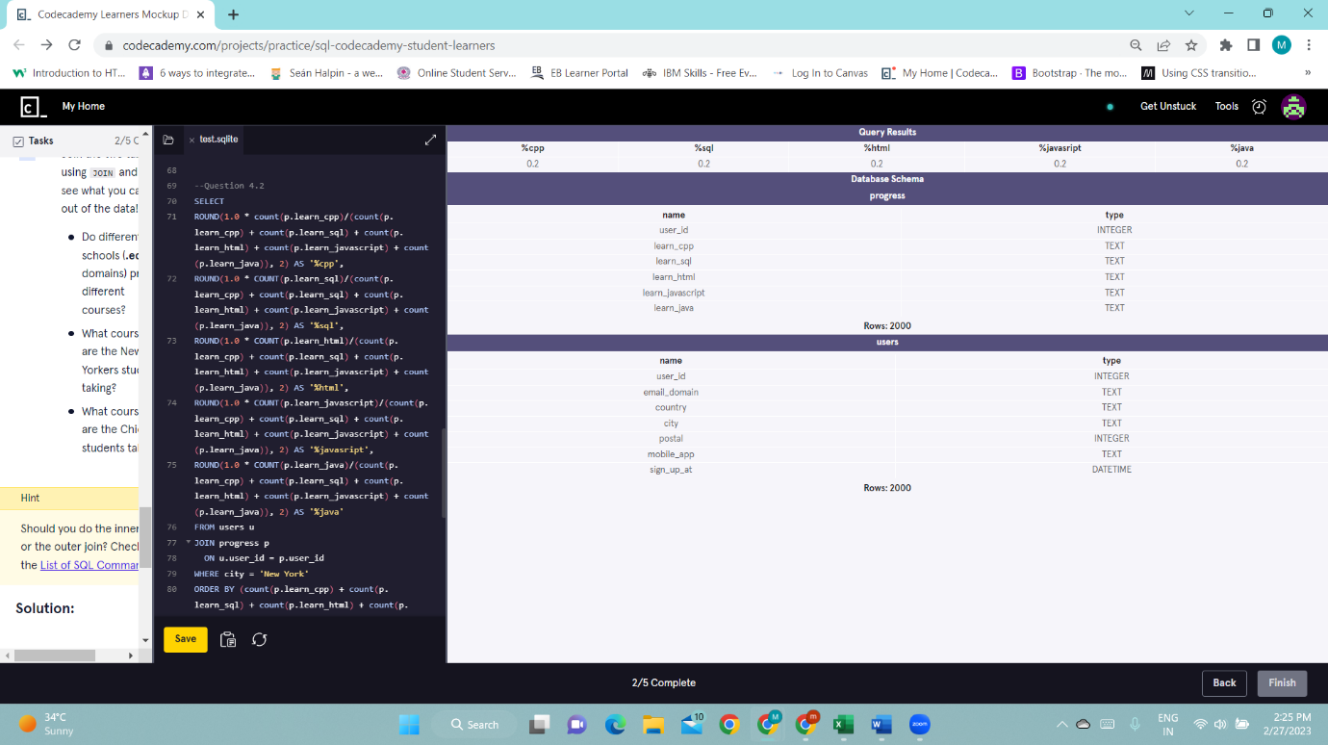

**-->Question 4.3 What courses are the Chicago students taking?**

**Ans:**

SELECT

ROUND(1.0 * count(p.learn_cpp)/(count(p.learn_cpp) + count(p.learn_sql) + count(p.learn_html) + count(p.learn_javascript) + count(p.learn_java)), 2) AS '%cpp',

ROUND(1.0 * COUNT(p.learn_sql)/(count(p.learn_cpp) + count(p.learn_sql) + count(p.learn_html) + count(p.learn_javascript) + count(p.learn_java)), 2) AS '%sql',

ROUND(1.0 * COUNT(p.learn_html)/(count(p.learn_cpp) + count(p.learn_sql) + count(p.learn_html) + count(p.learn_javascript) + count(p.learn_java)), 2) AS '%html',

ROUND(1.0 * COUNT(p.learn_javascript)/(count(p.learn_cpp) + count(p.learn_sql) + count(p.learn_html) + count(p.learn_javascript) + count(p.learn_java)), 2) AS '%javasript',

ROUND(1.0 * COUNT(p.learn_java)/(count(p.learn_cpp) + count(p.learn_sql) + count(p.learn_html) + count(p.learn_javascript) + count(p.learn_java)), 2) AS '%java'

FROM users u

JOIN progress p

ON u.user_id = p.user_id

WHERE city = 'New York'

ORDER BY (count(p.learn_cpp) + count(p.learn_sql) + count(p.learn_html) + count(p.learn_javascript) + count(p.learn_java)) DESC;

